**Big Data Management - Assignment 7**

**MongoDB to load and query TPC-H data**

**Akshay Kumar (G24AI1033)**

**GitHub Link –** [**Assignment7**](https://github.com/Akshaykumarky26/BigDataManagement/tree/main/Assignment%205)

**MongoDB Atlas Setup:** Successfully created and connected to your COSC516 MongoDB Atlas cluster.

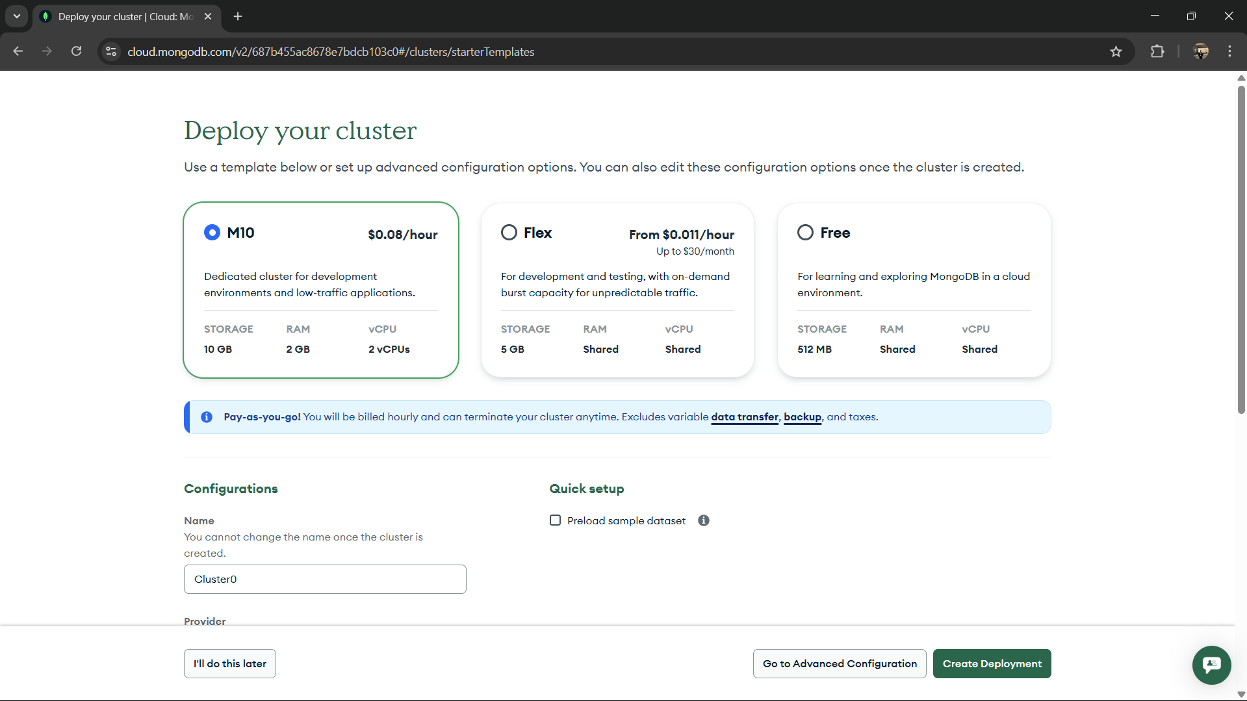

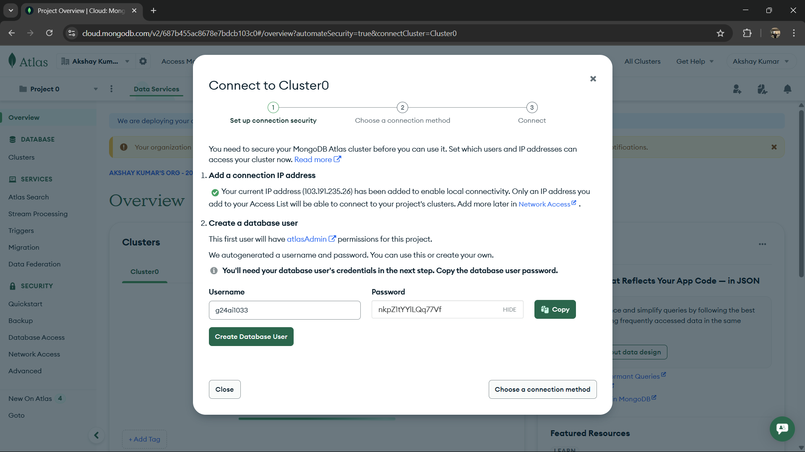

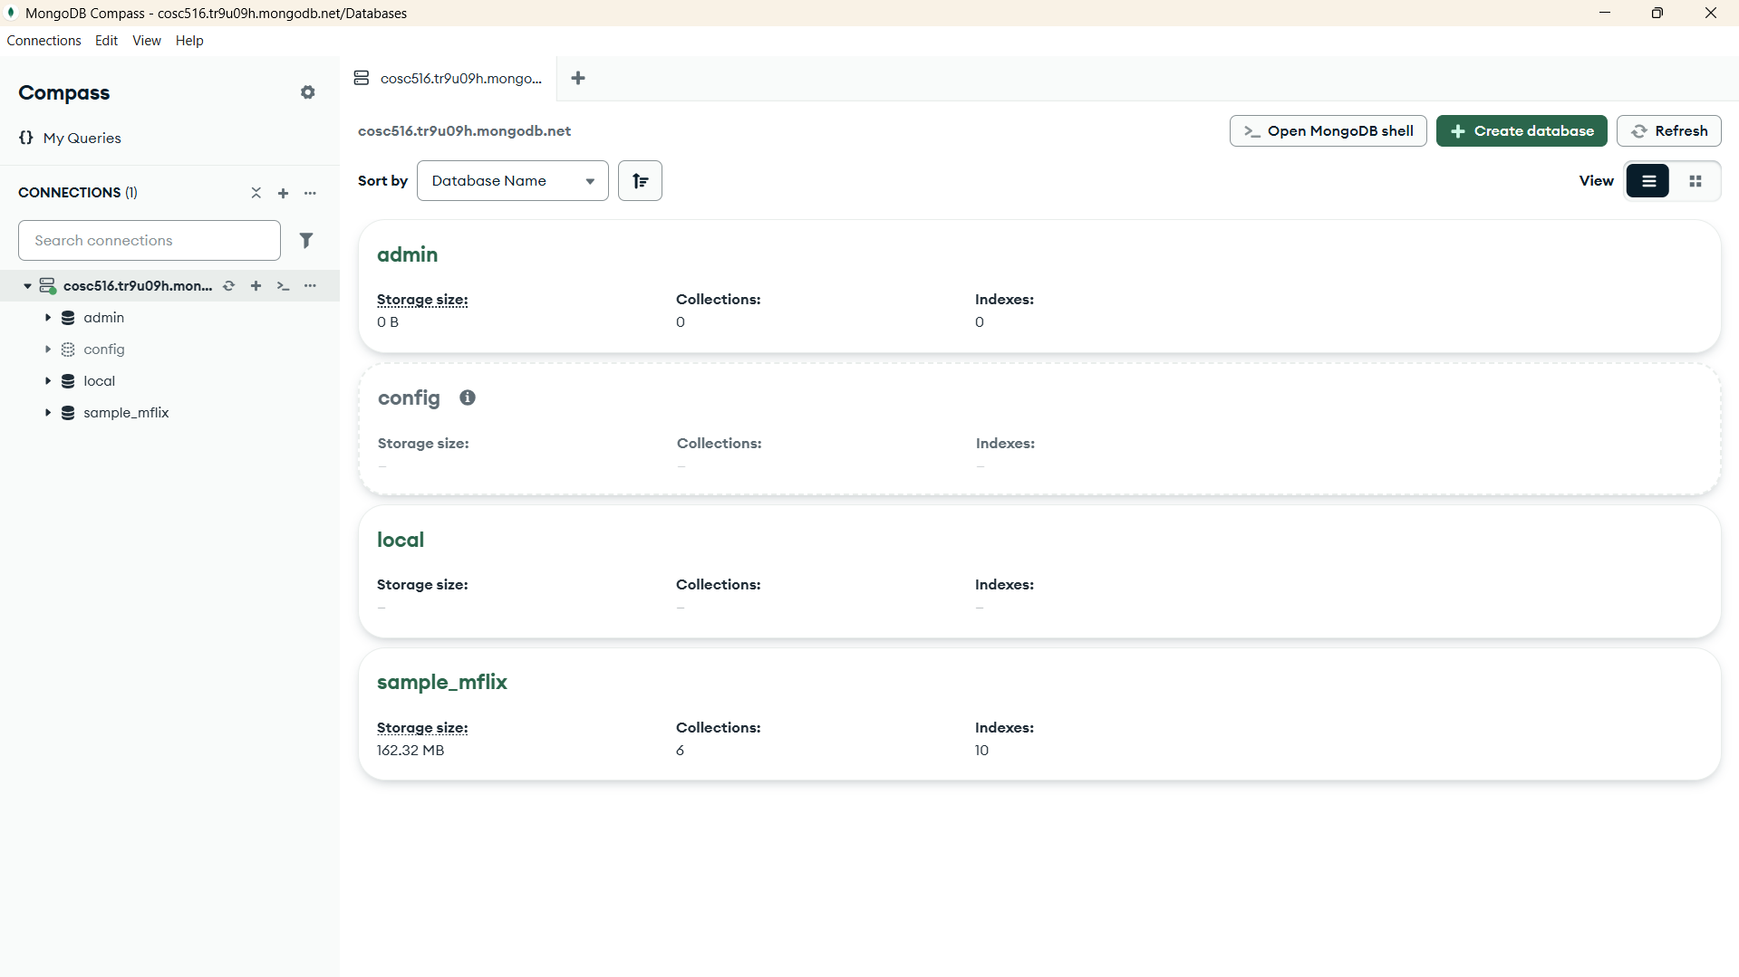

Step 1: Copy the starter code in the Assignment pdf to a new file in the projector structure and name it MongoDB.java

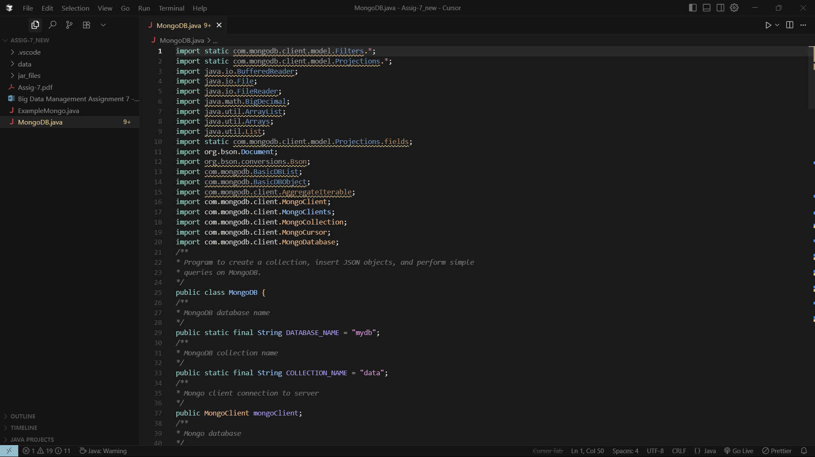

Step 3: Add the reference libraries from the jar_files

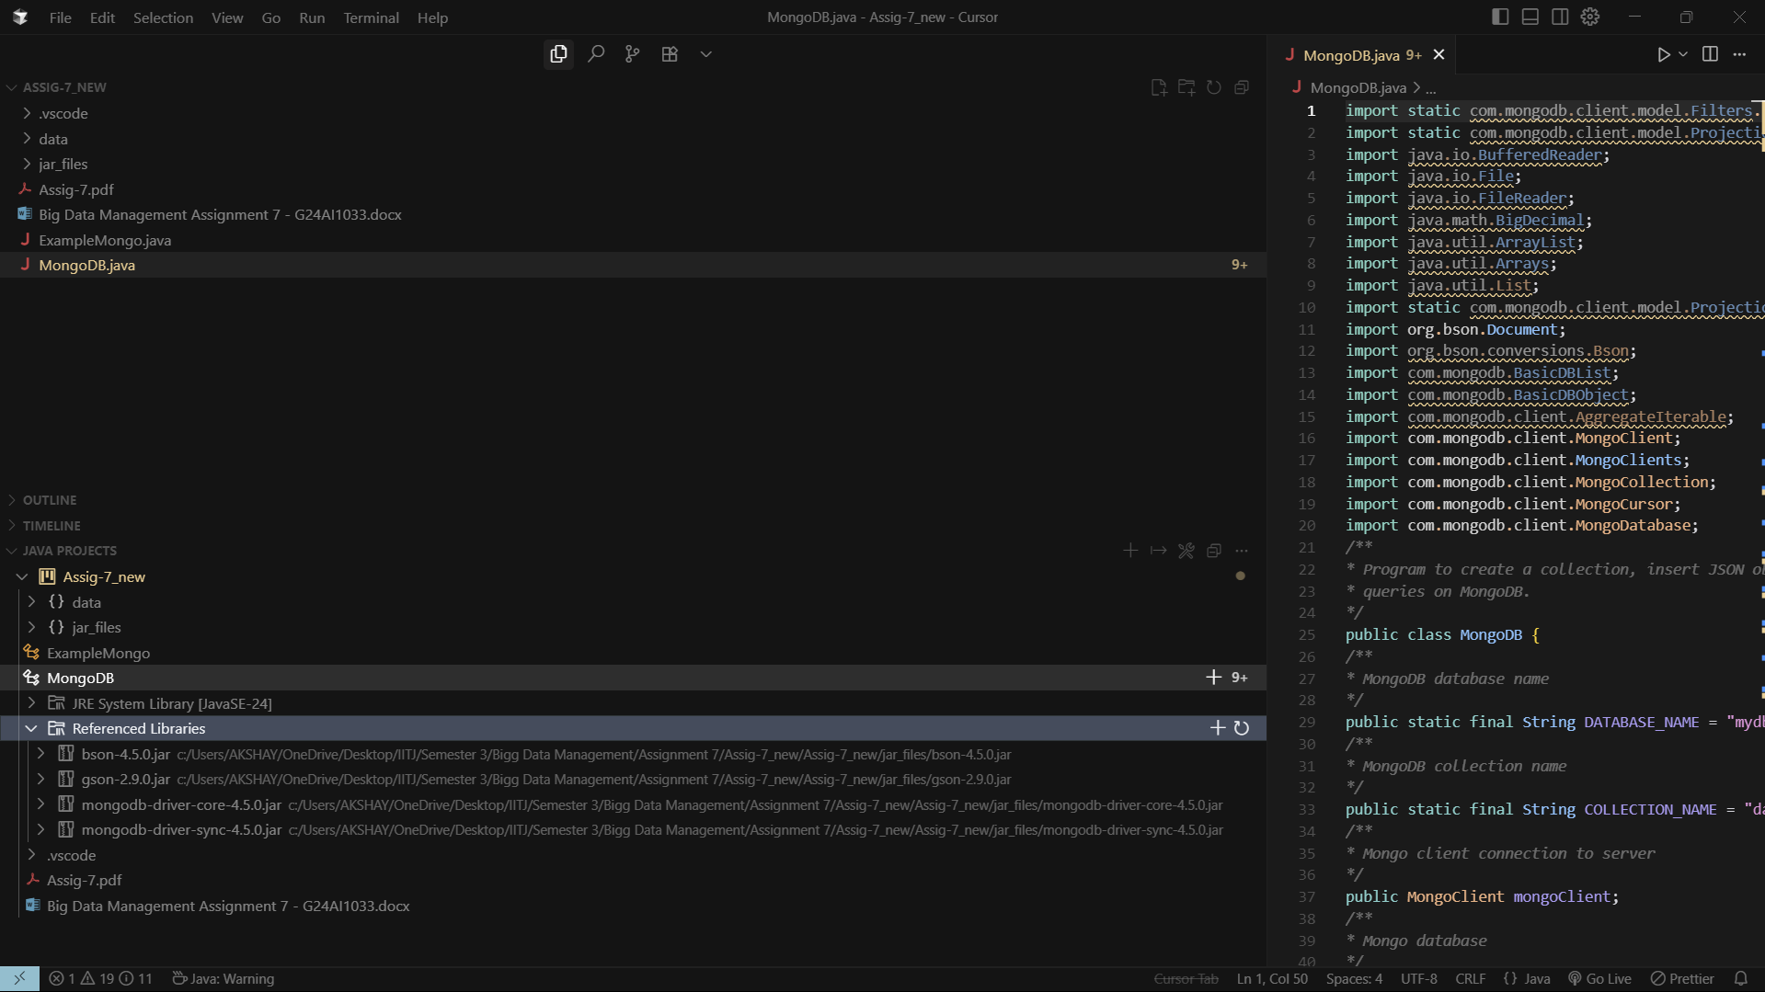

**Step 4:** We will complete the connect() method in MongoDB.java to establish a connection to our MongoDB Atlas cluster.

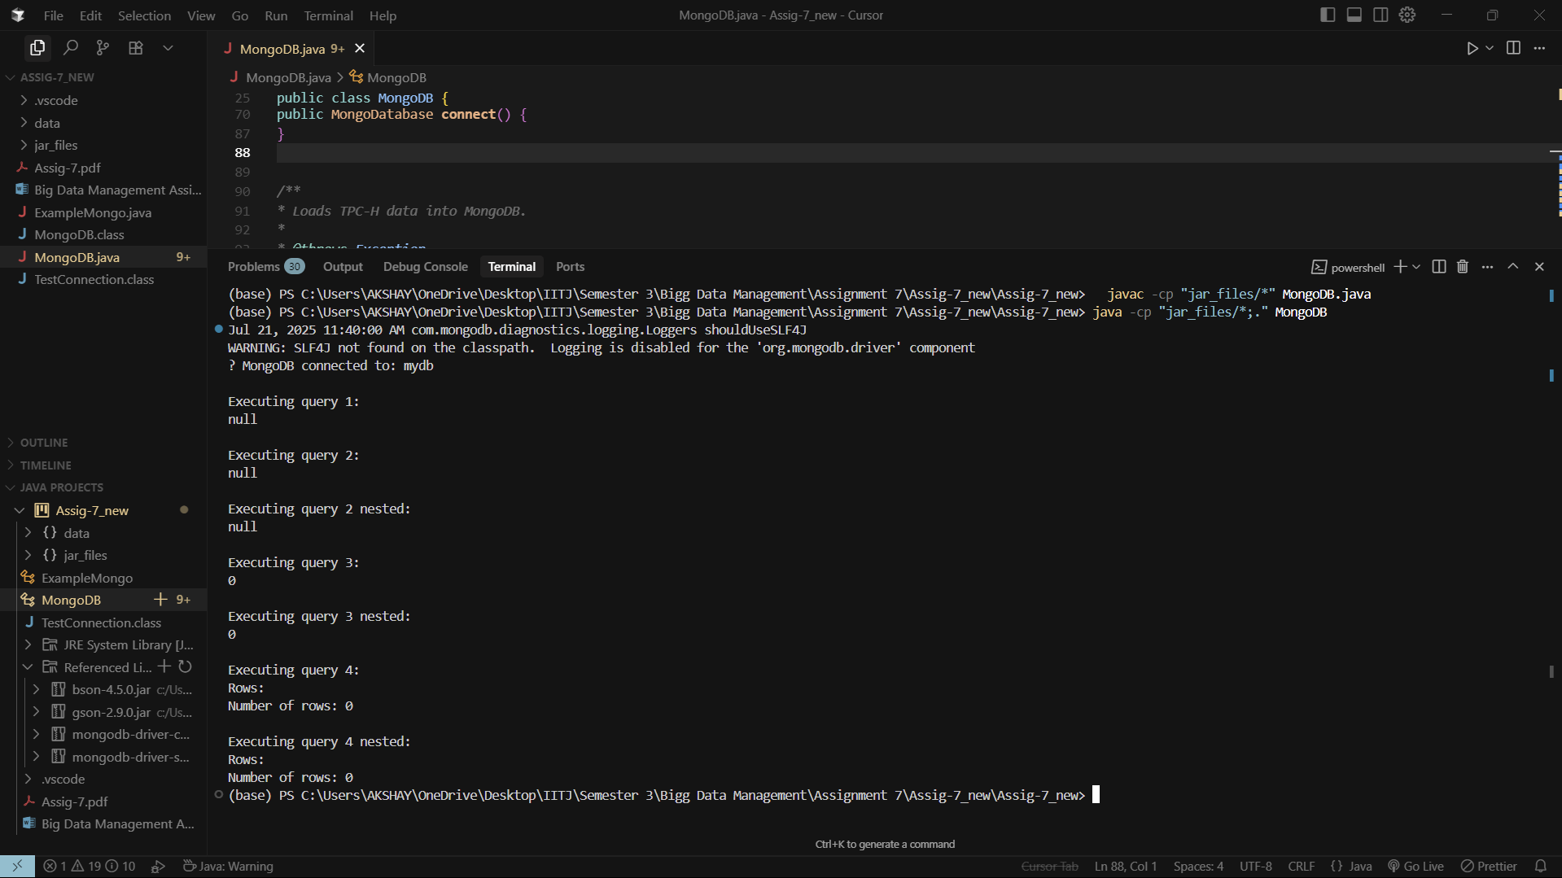

**Task 1 load():** Loaded TPC-H customer.tbl and order.tbl data into separate customer and orders collections.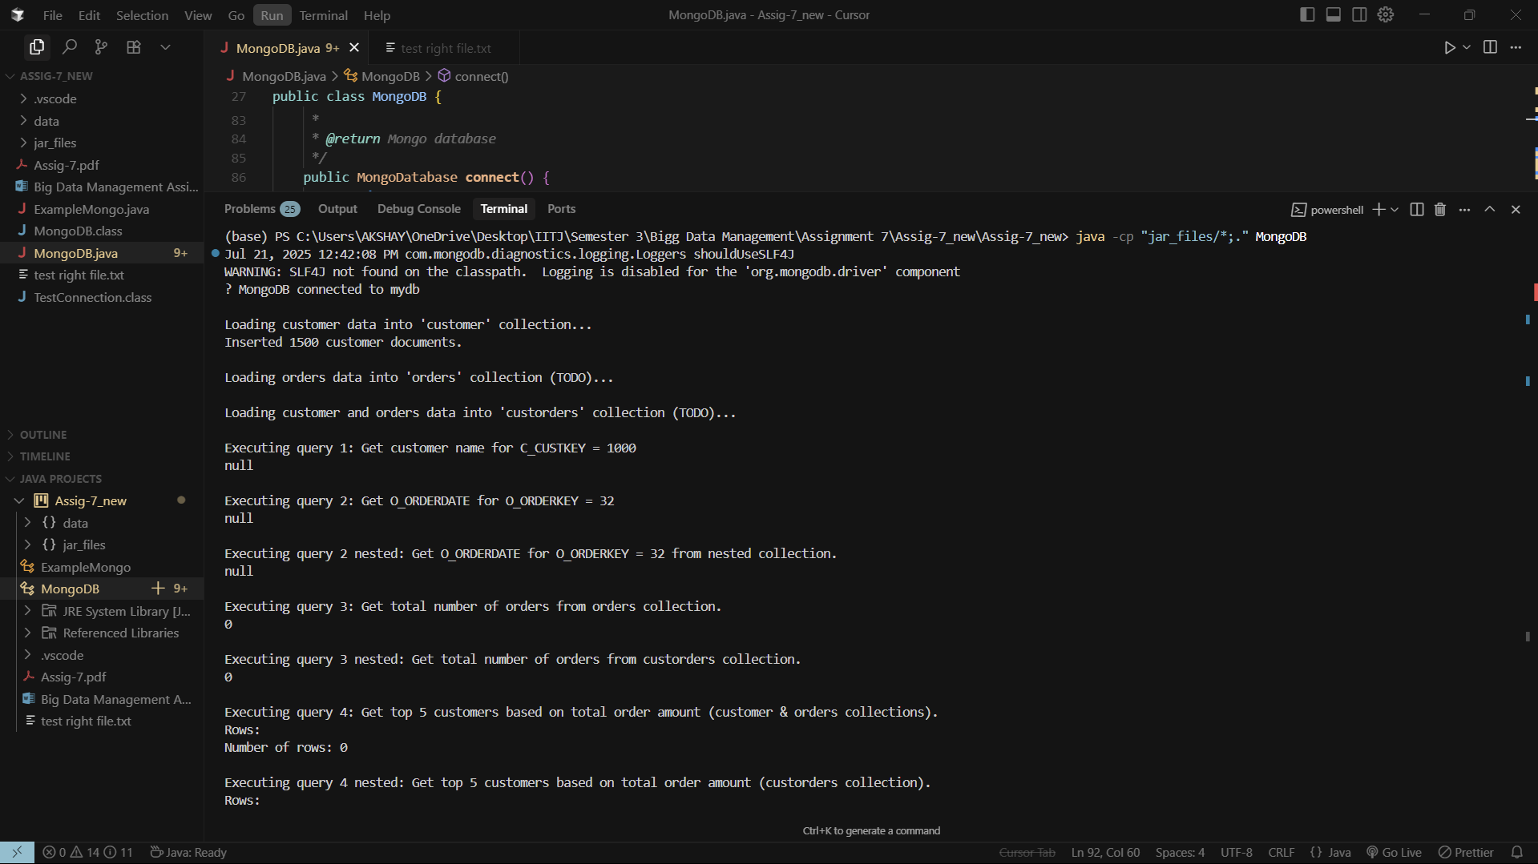

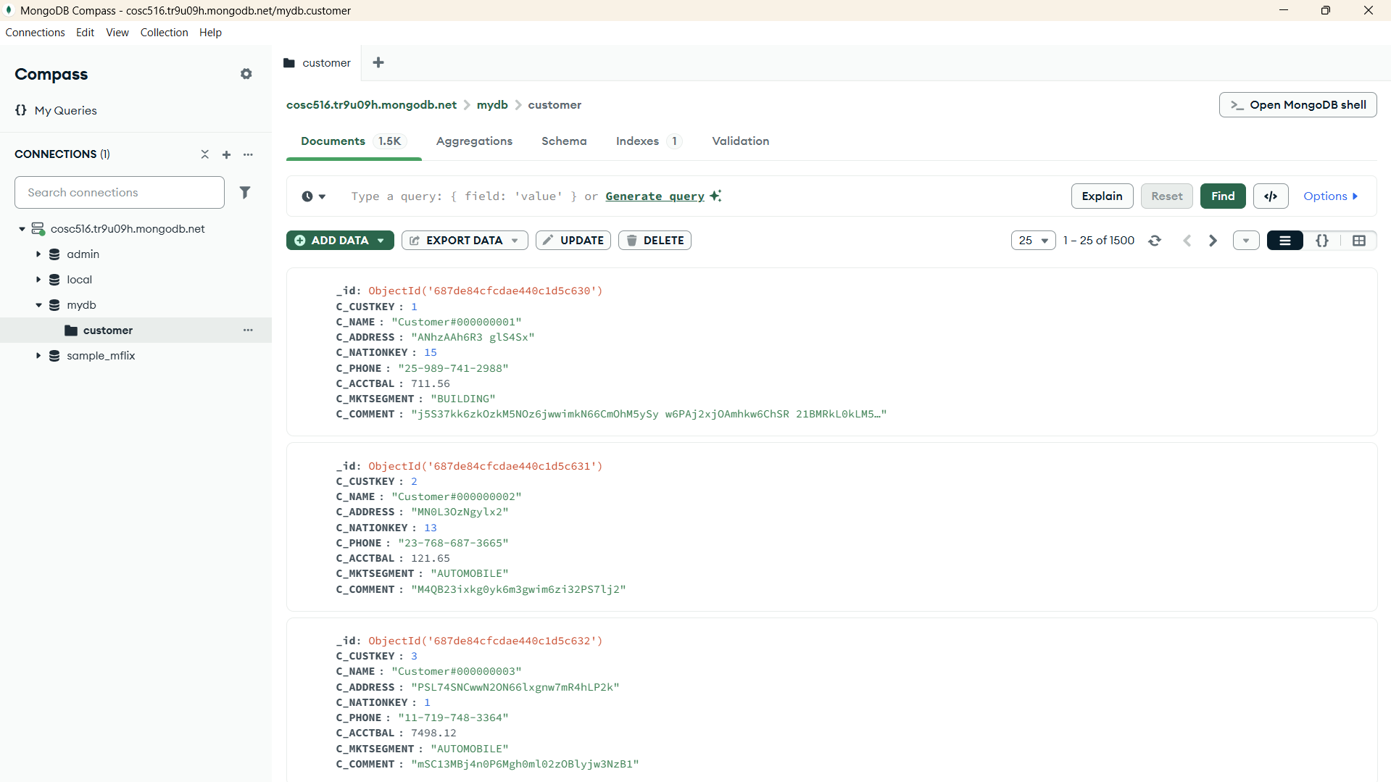

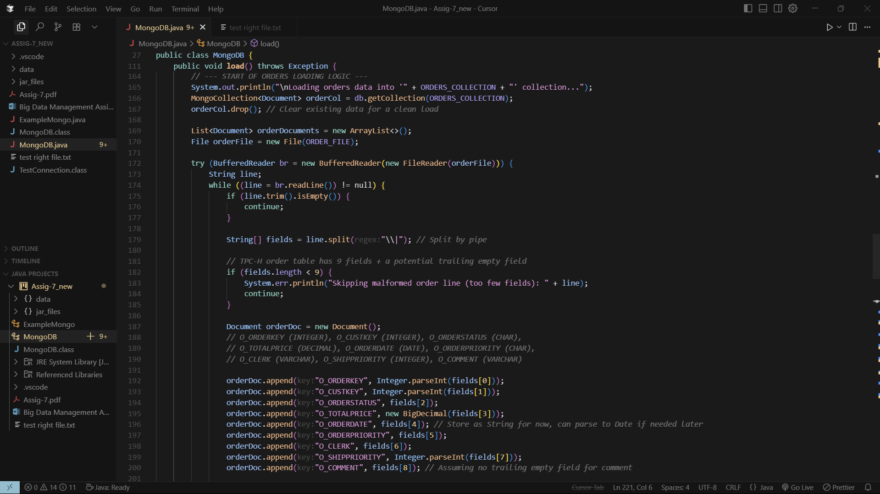

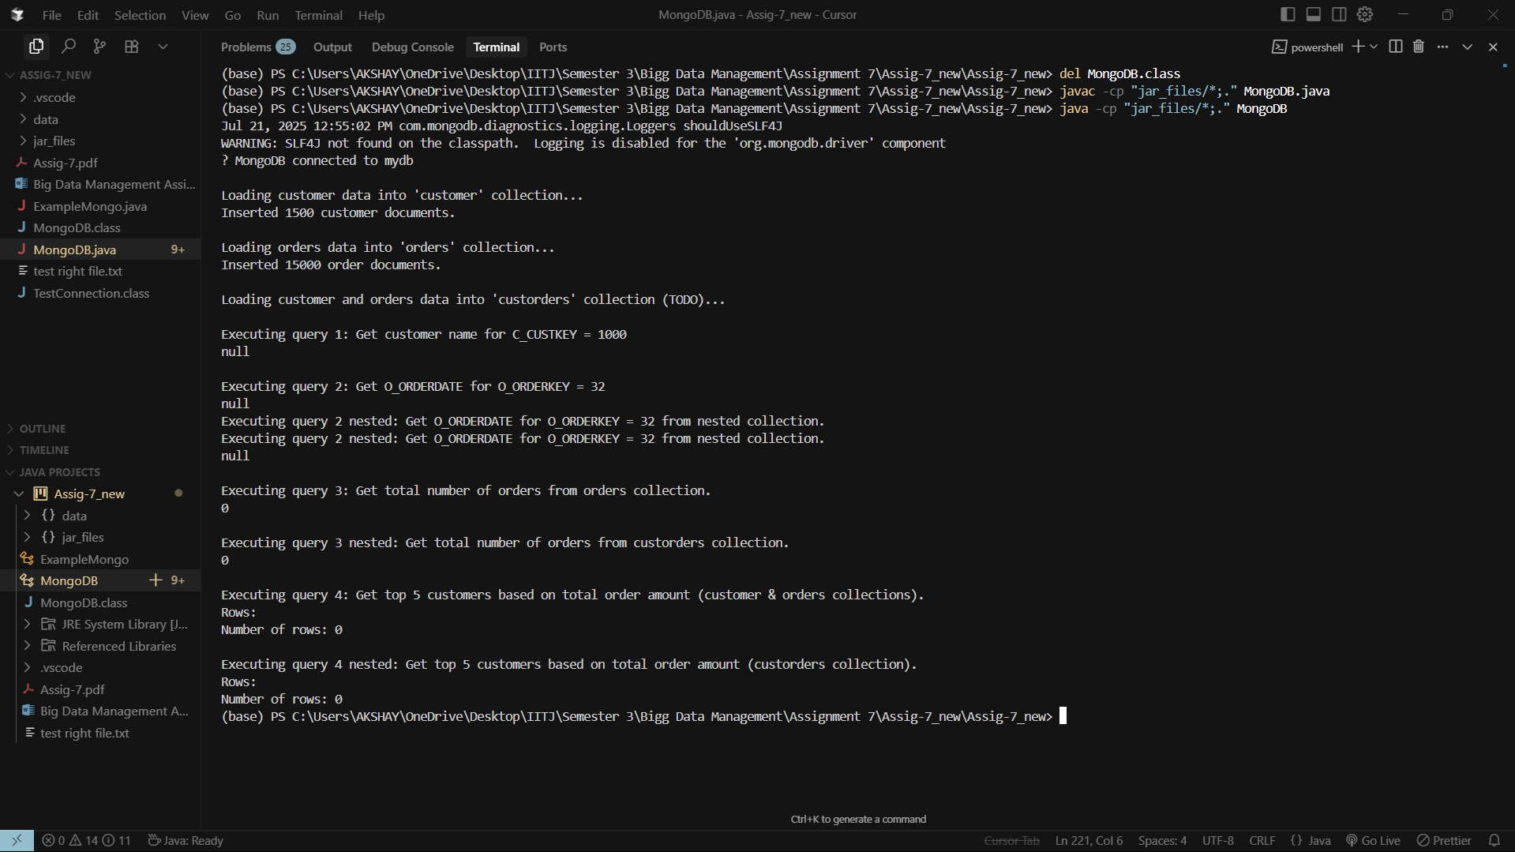

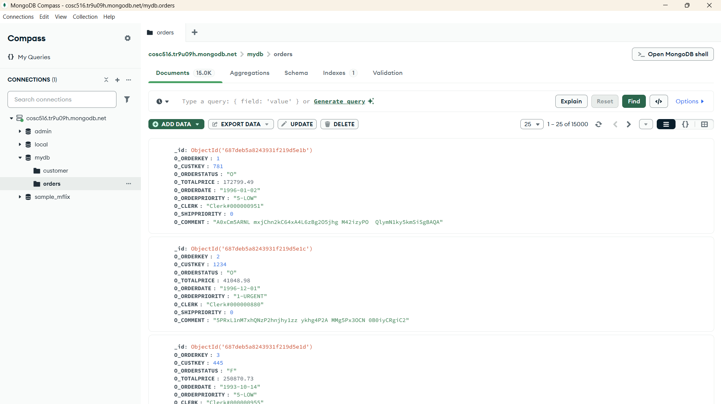

**Task 2 loadNest():** Loaded TPC-H customer and order data into a nested custorders collection.

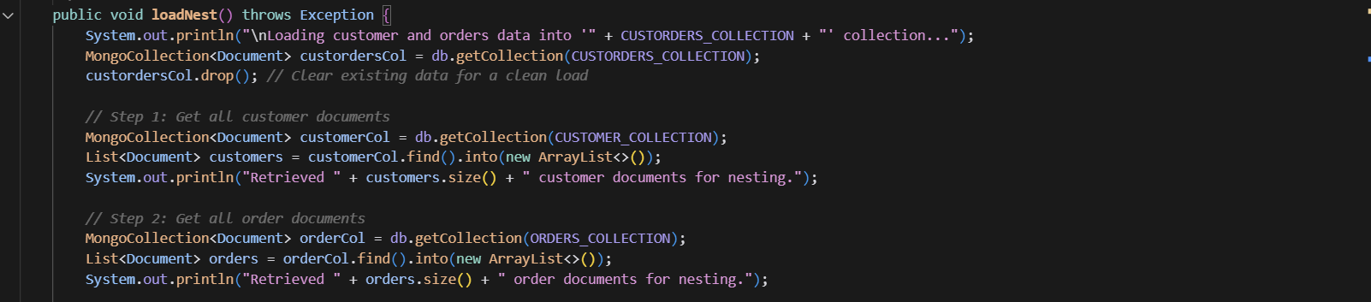

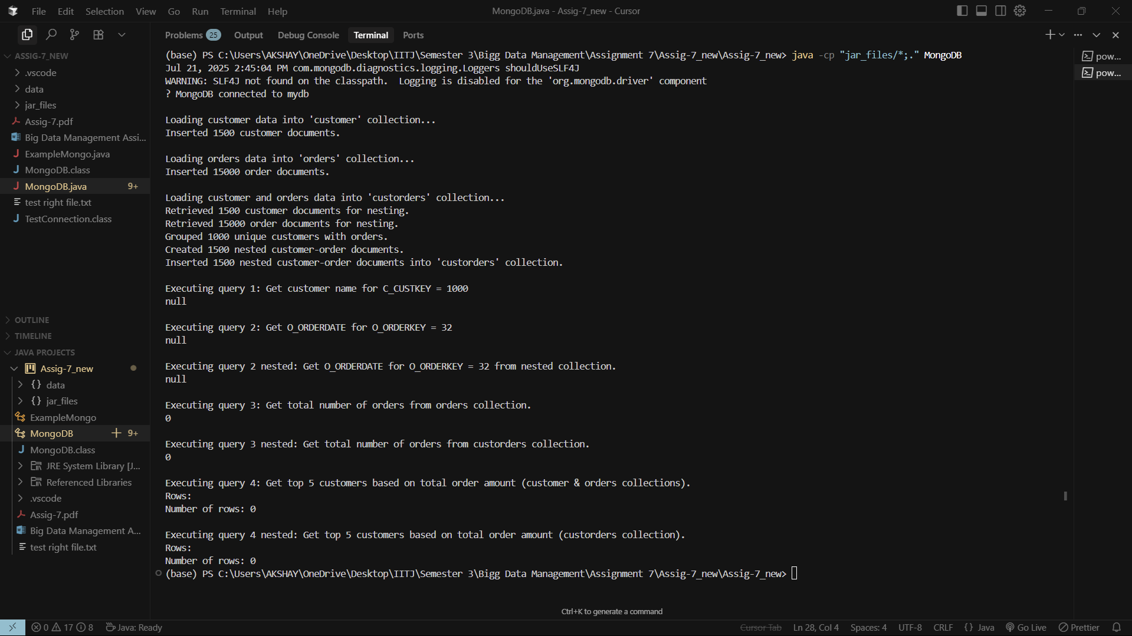

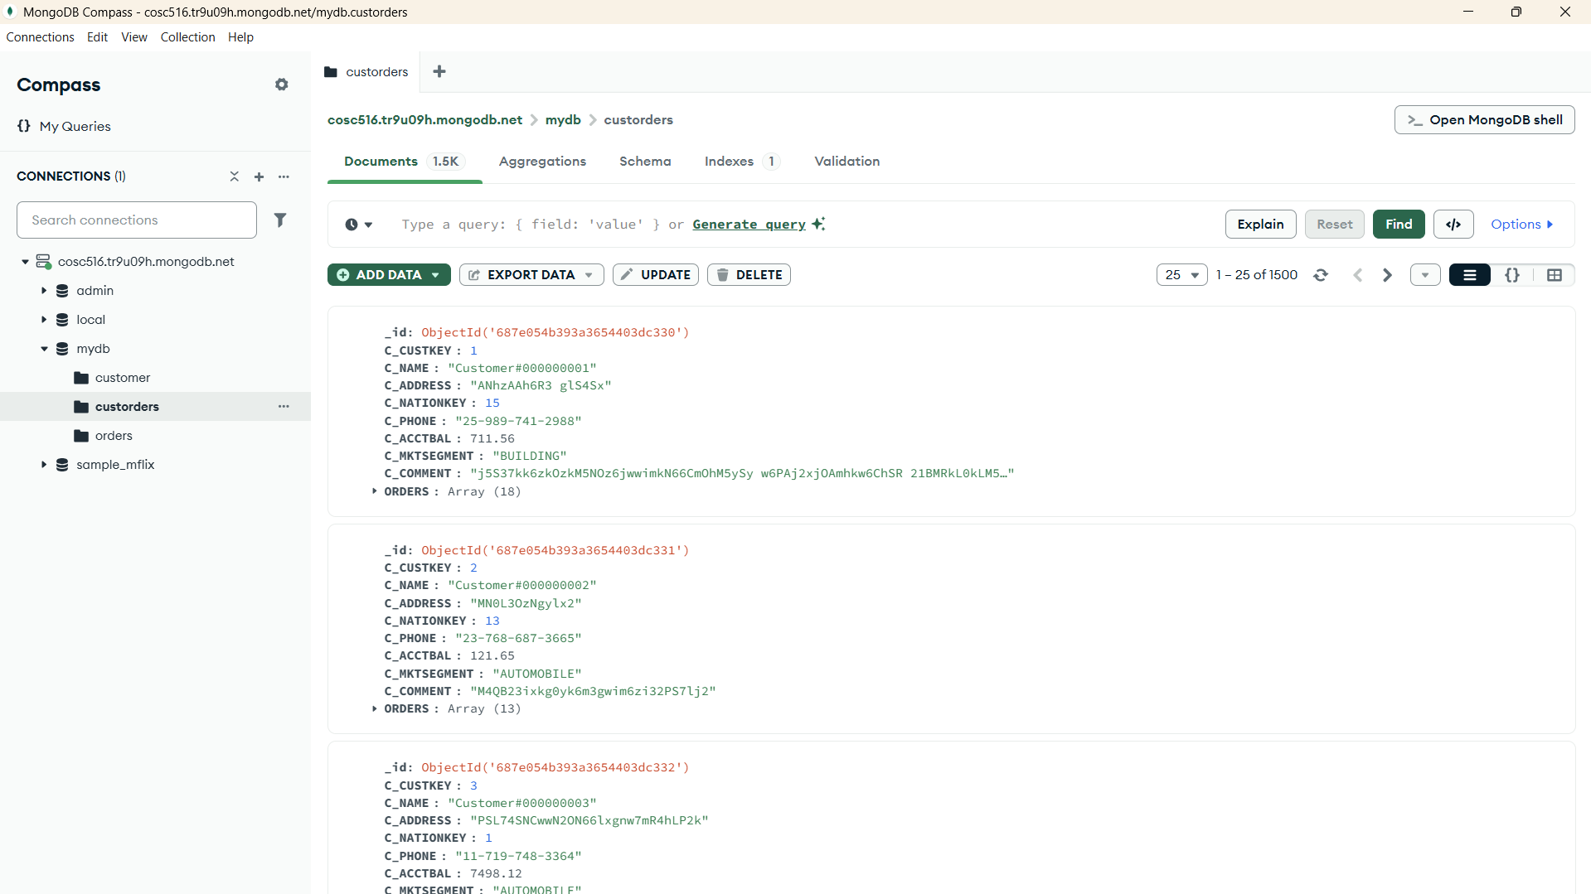

**Task 3 - query1():** Retrieved customer name by customer ID from the customer collection.

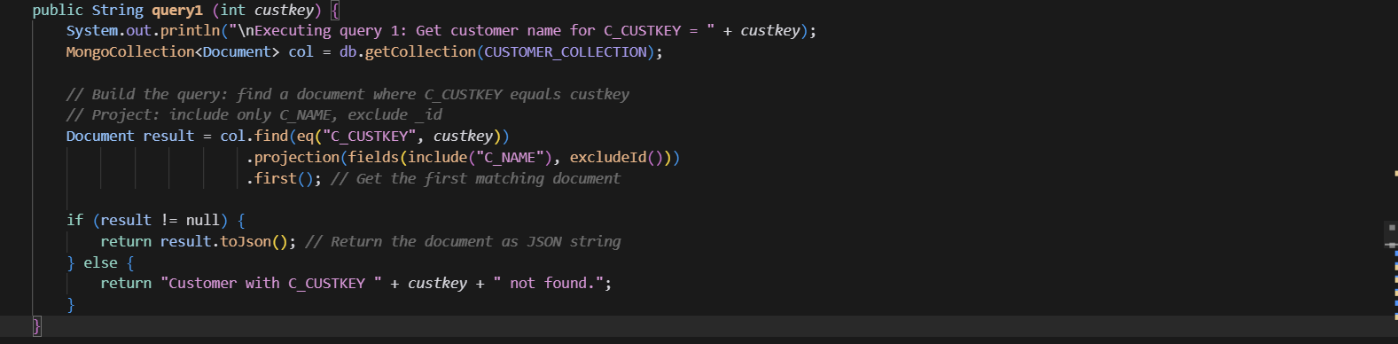



**Task 4 - query2():** Retrieved order date by order ID from the orders collection.

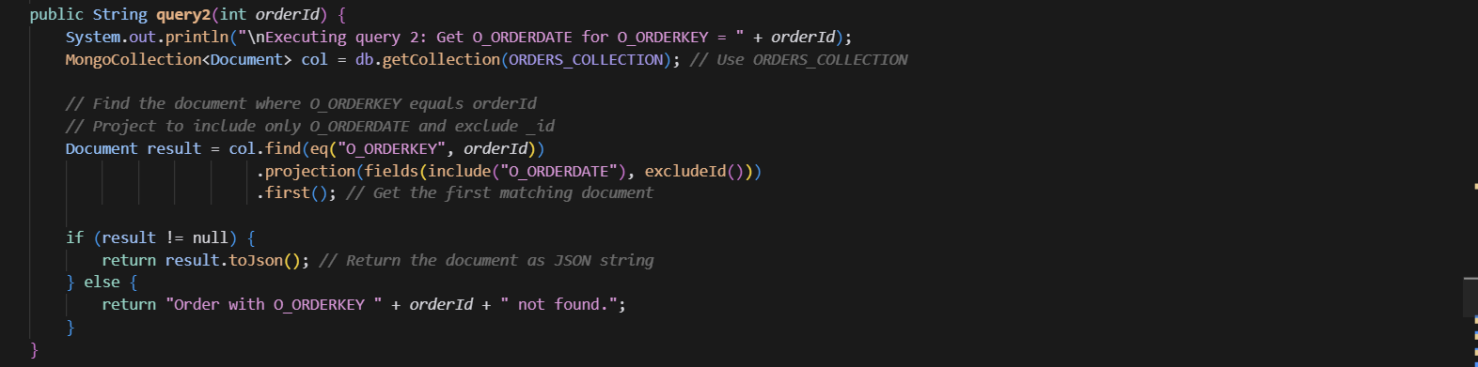



**Task 5 - query2Nest():** Retrieved order date by order ID from the custorders (nested) collection.

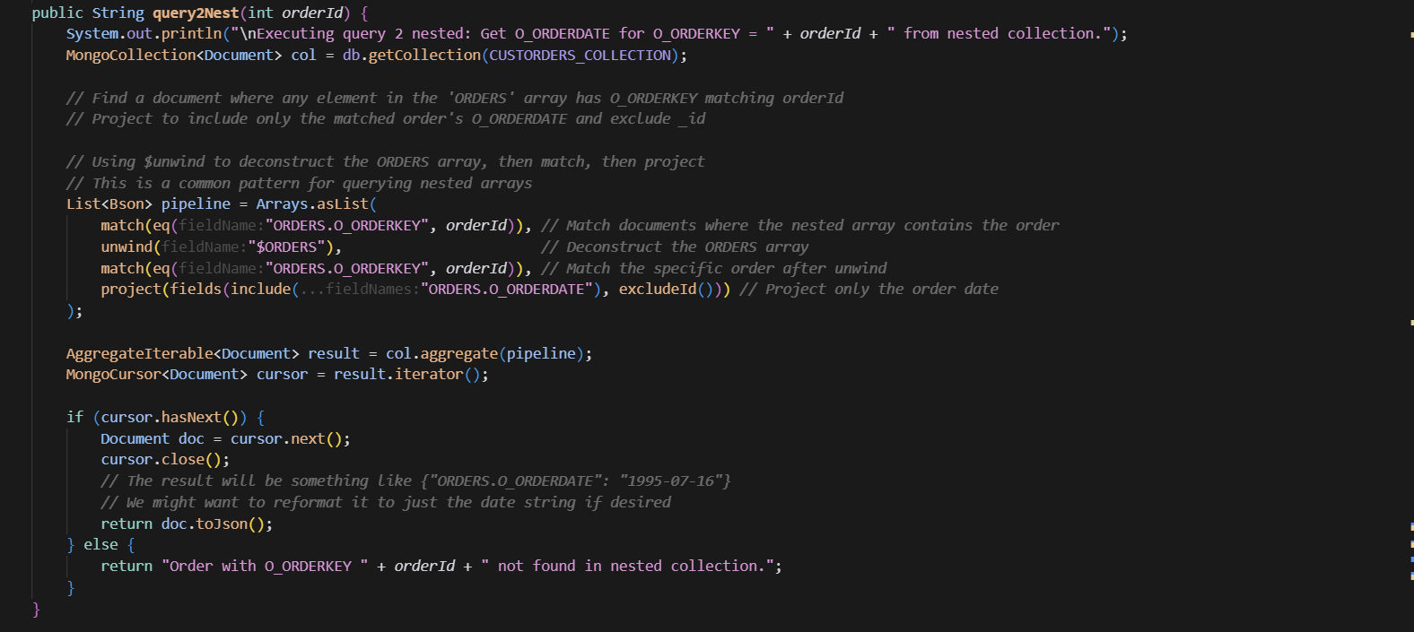



**Task 6 - query3():** Returned the total number of orders from the orders collection.

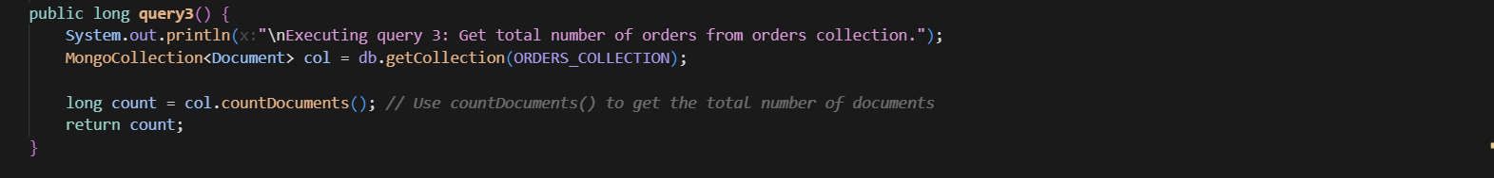



**Task 7(query3Nest():** Returned the total number of orders from the custorders (nested) collection.

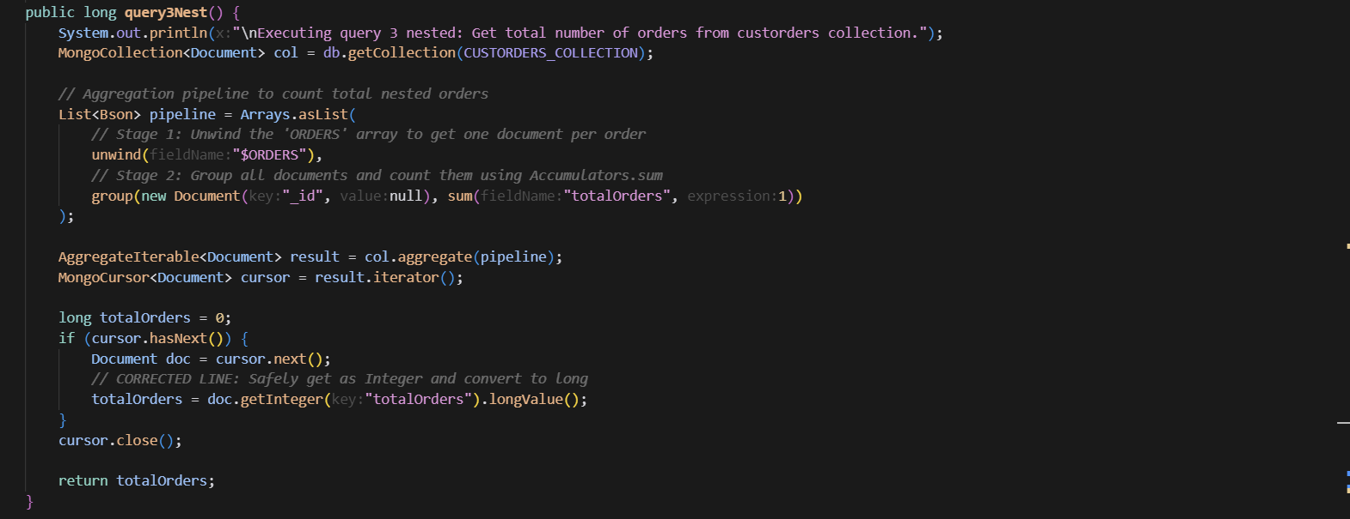



**Task 8 - query4():** Returned the top 5 customers by total order amount using the customer and orders collections.

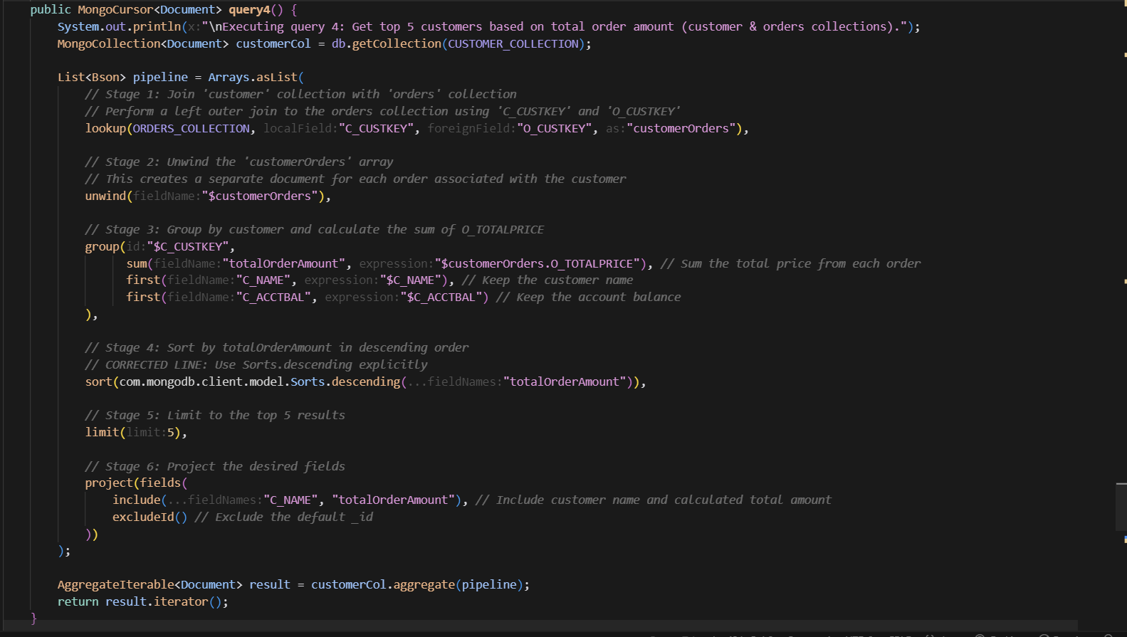

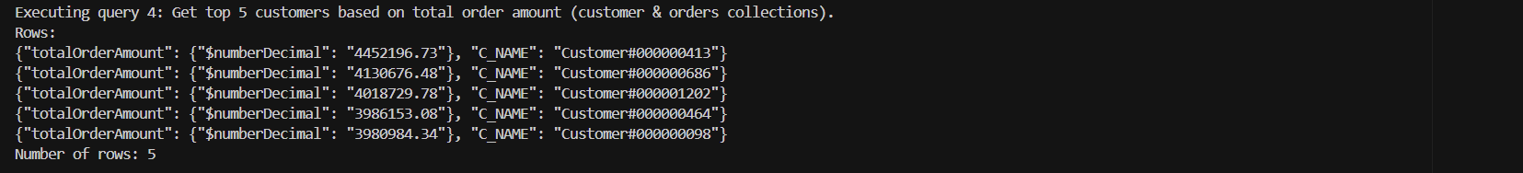

**Task 9 query4Nest():** Returned the top 5 customers by total order amount using the custorders (nested) collection.

